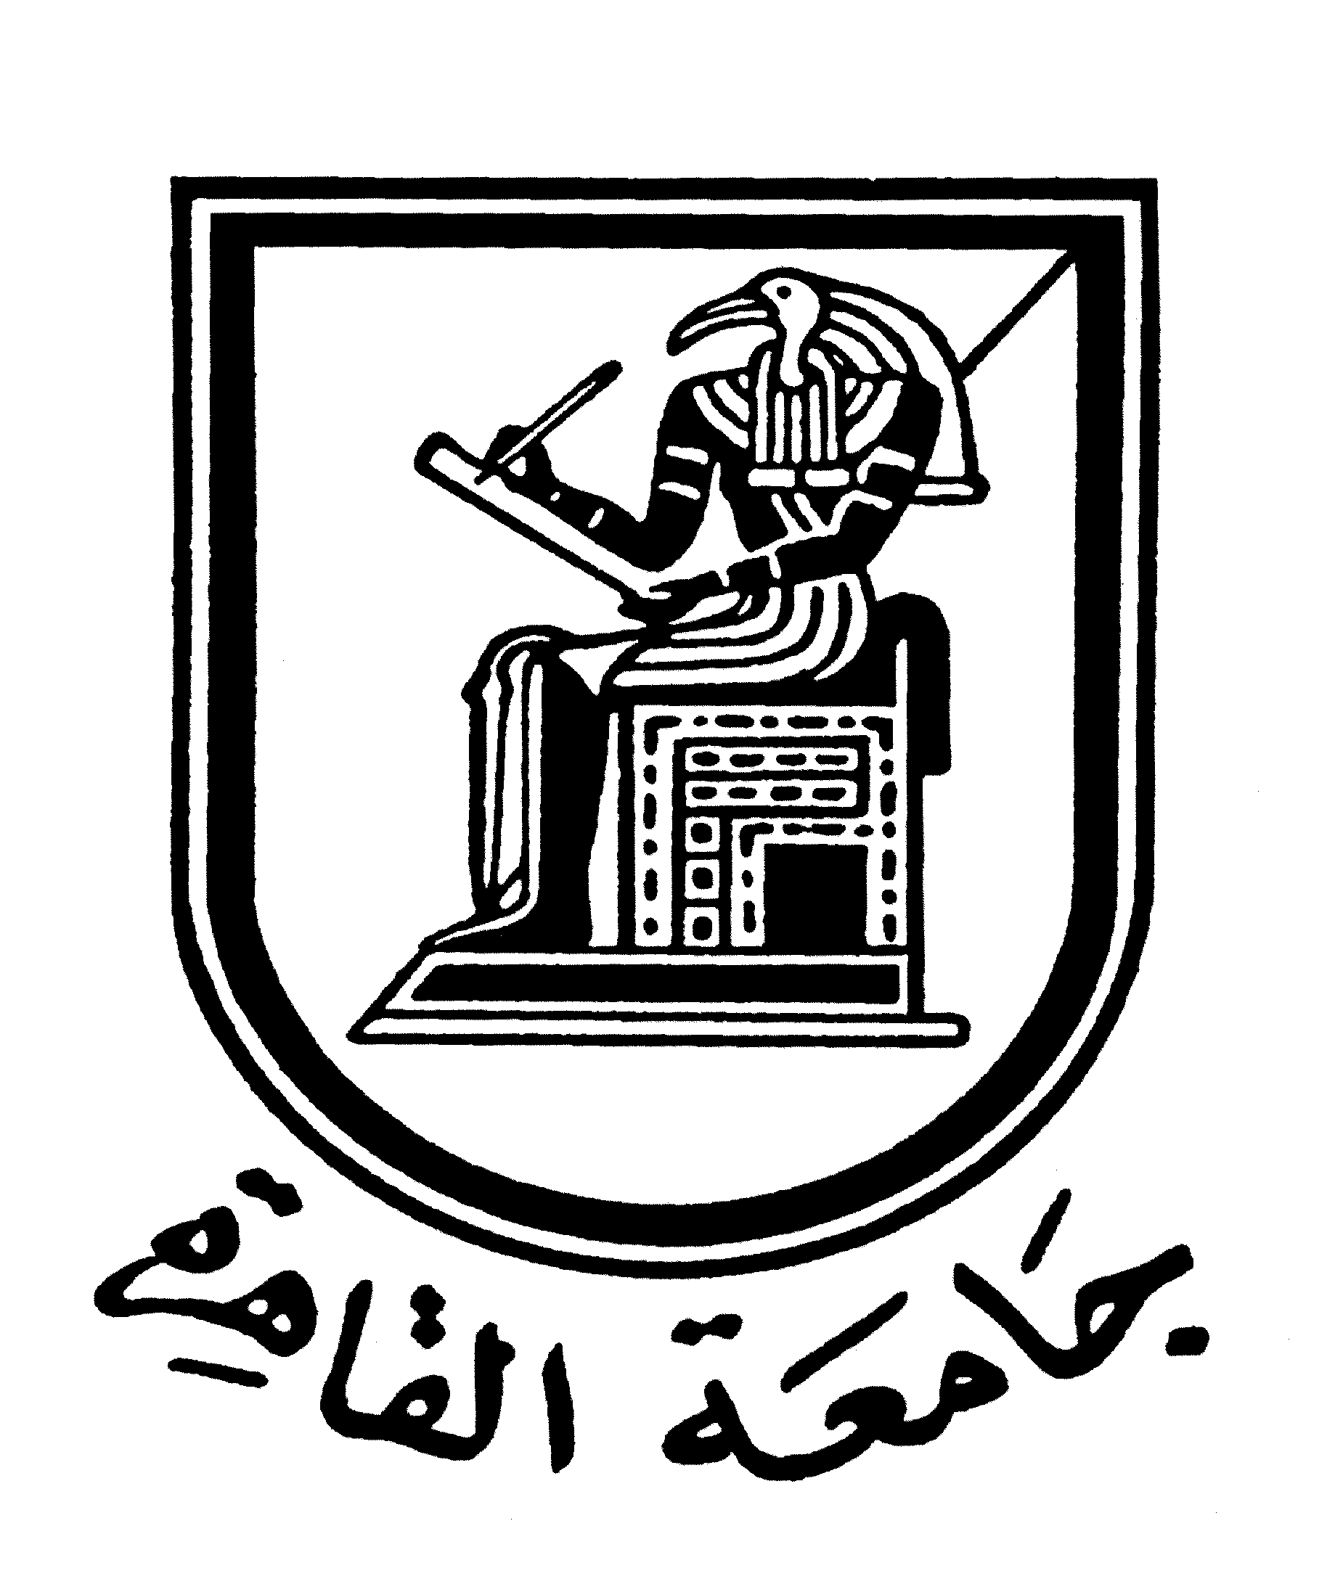 |  | 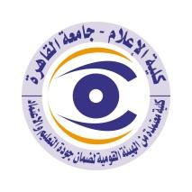

Brief CV (of the members of the academic staff)
Name: Hayat Bader Qurany
Academic Department: Public Relation and Advertising
Academic degree: Teacher.
The title of the master’s thesis, the year and the entity it was obtained from:
Means of International Media and Conversation Management between Civilizations, 2011.
The title of the doctoral thesis the year and the entity it was obtained from:
The Evaluation of Media Diversity Standards in Egyptian Means of Media, 2018.

Courses taught in the Bachelor program:
Translation 1, PR writing, media literacy, media and society, business communication.
The most important reference books issued by the faculty member to benefit from his scientific research (a maximum of five books):
None
The five most recent academic researches that have been published:
1- Evaluating the digital education skills among the students of Mass Communication faculties within the experiment of remote learning.
2- Islam and west a semantic analysis on Christchurch attack.
3- Communicating nation branding through media and marketing strategies : a second analysis review.

The most recent five scientific theses (Master's and Ph.D.) that have been supervised:
Lama Atef thesis: Advertising literacy on Instagram.
Mennah Ahmed thesis: E-commerce on social media.
Rahma Mohammed thesis: guerrilla marketing strategies in Egypt.
Other activities of the member of the academic staff in order to develop the educational process and serve students other than the teaching activity:
Training Coordinator in the department of Public relations and Advertising and in the English division.
The most important leading positions that have been held:
The manager of the Electronic Learning Unit.
Member of the Board of Directors of the Faculty of Mass Communication Marketing Agency.
Postgraduate Standard Coordinator, Quality Unit.
The secretary of Public relations and Advertising magazine.

The most important local and international awards obtained, the year when awarded and the entity awarded them:
Amman University award for the best developmental graduation project on e-learning, second place, 2021.
Media and Digital Transformation Foundation Award for Graduation Projects, 2021.
Shrook Festival Award for Essiwan Graduation Project, 2021.

Mobile: 01009722206
email address:hayatmoatasem1984@gmail.com

