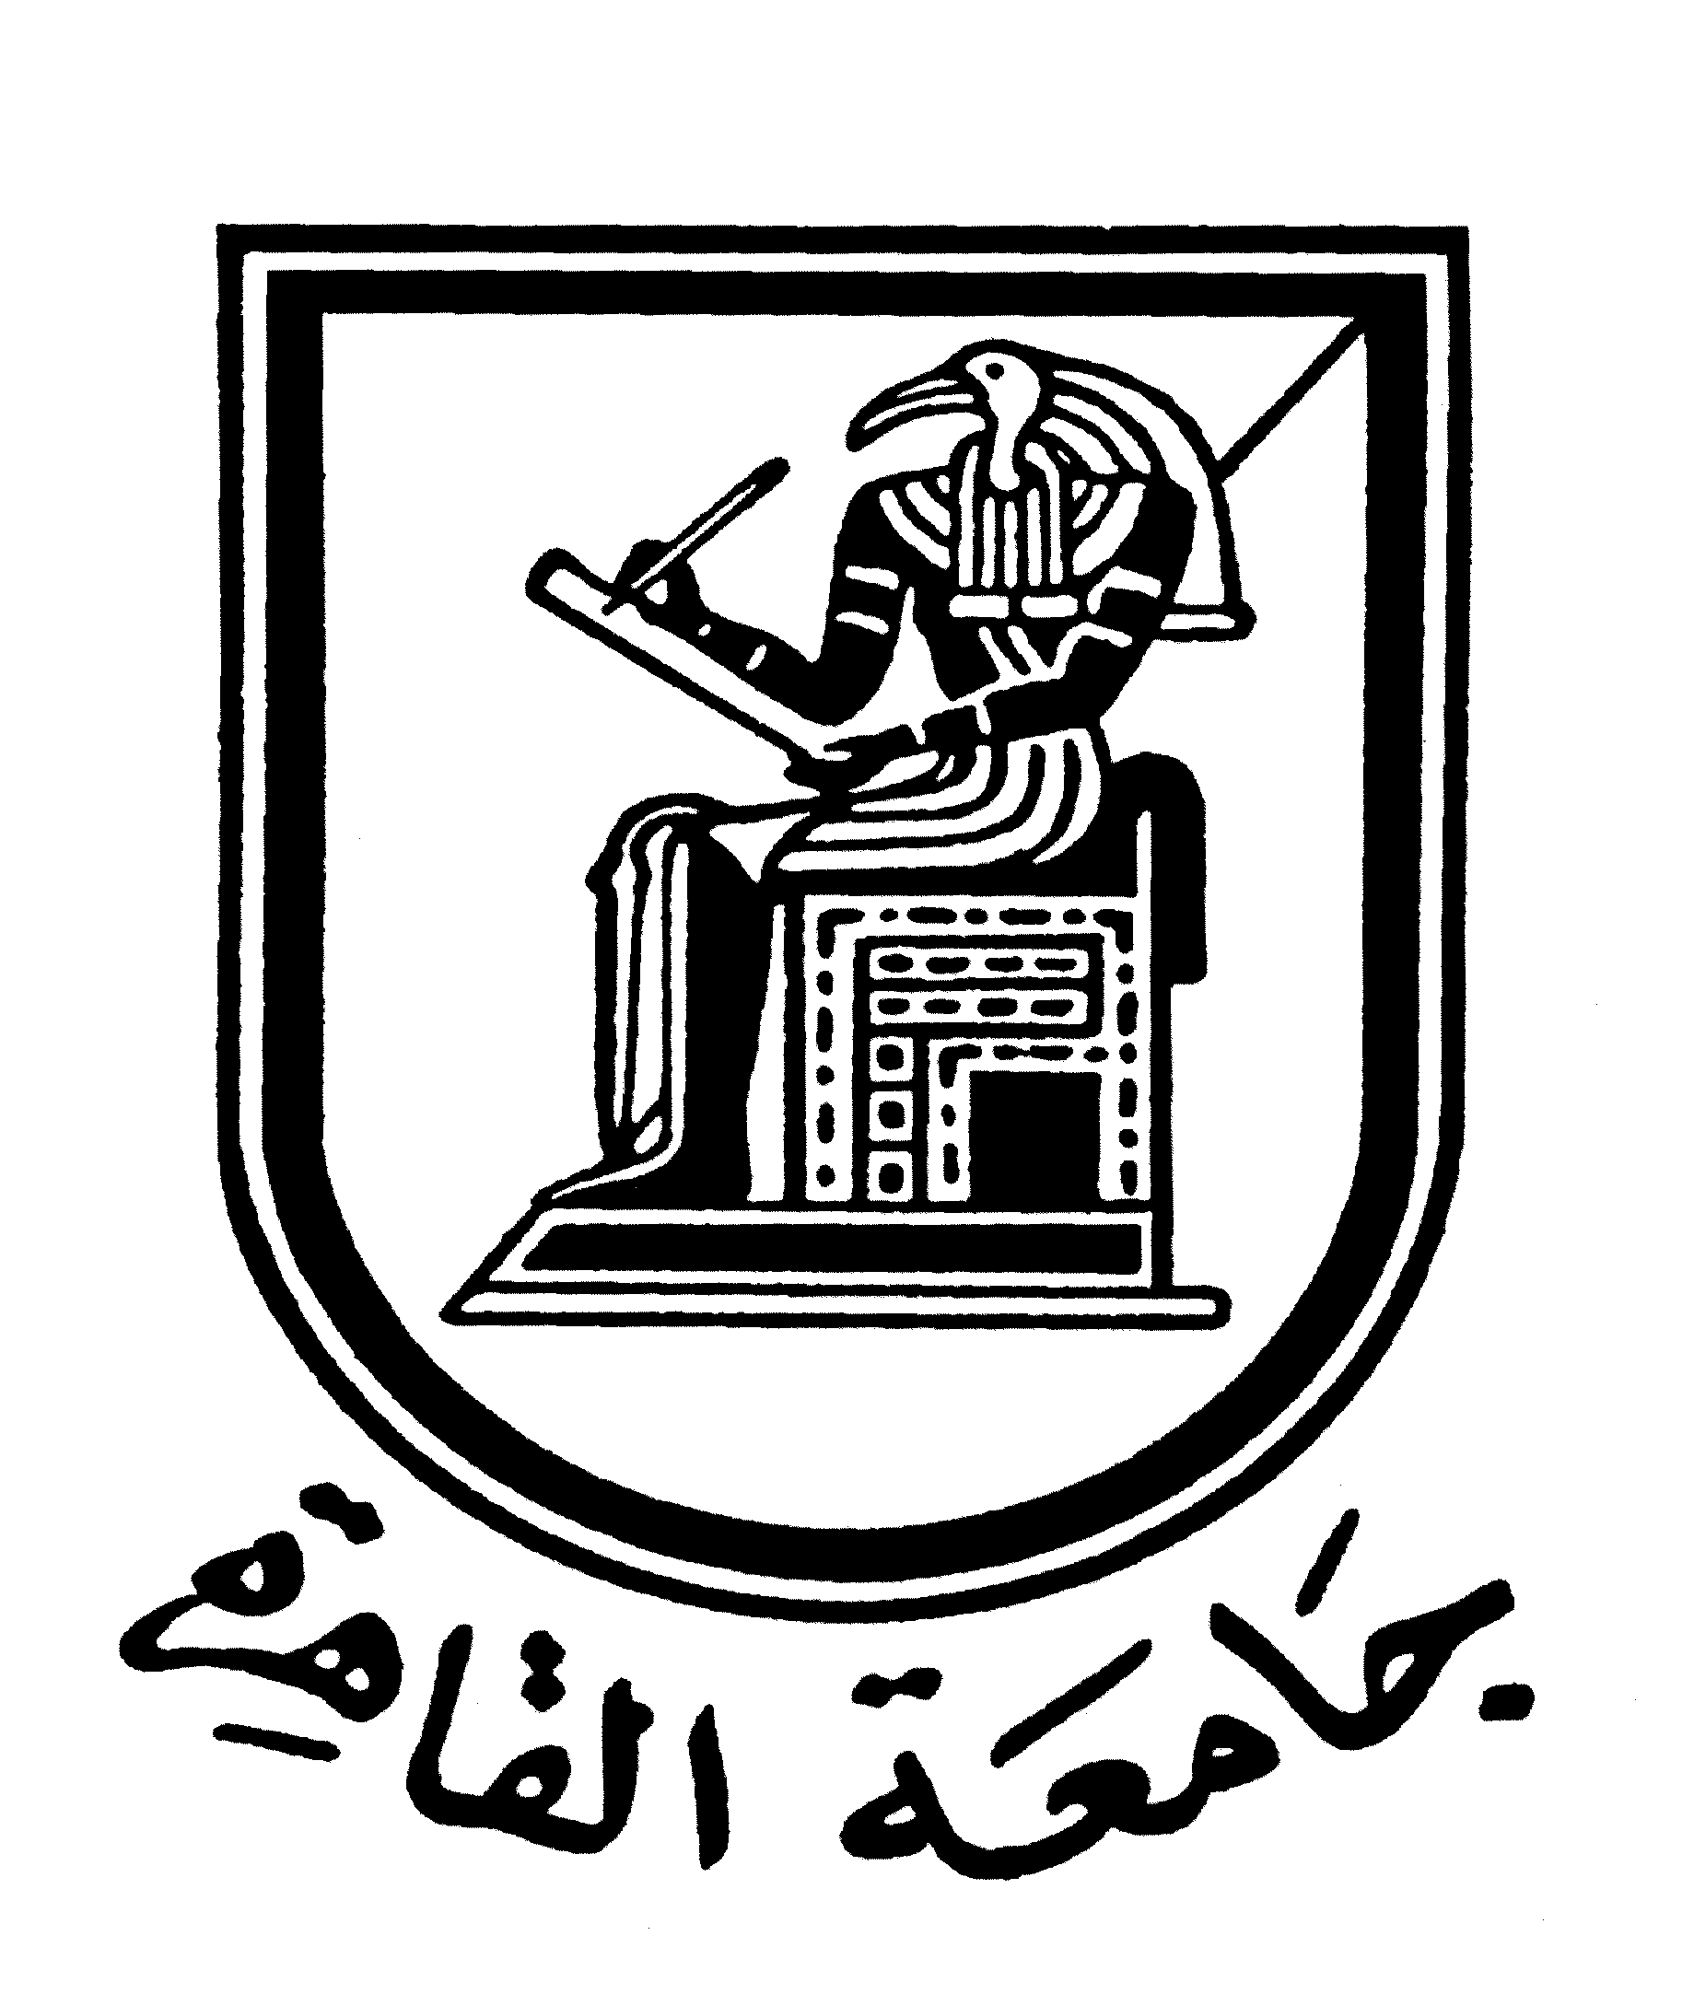 | 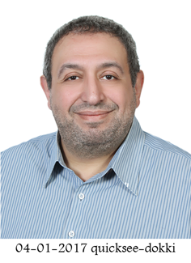 | 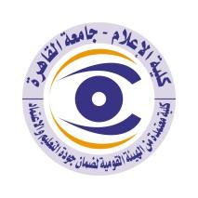

Brief CV (of the members of the academic staff)
- Name: Hani Mohammed Ali
- Academic department: Journalism
3-Academic degree: Teacher
4-The title of the master’s thesis, the year and the entity it was obtained from:
Masters in Journalism in 1997 entitled (Factors Affecting Press Editing in Weekly News Magazines in the United States and Egypt - A Comparative Study) Faculty of Mass Communication - Cairo University.
5- The title of the doctoral thesis the year and the entity it was obtained from:
PhD in journalism in 2004 entitled (The impact of the artistic construction of journalistic forms on readers’ attitudes towards content - a quasi-experimental study) Faculty of Mass Communication - Cairo University.
6- Courses taught in the Bachelor program:
- Press editing (news - hadith - investigation - report – article)
- Specialized press (political - economic - sports - technical)
- Media and press translation in English
- Research methods and specialized research (effect and being affected studies and empirical studies).

7- The most important reference books issued by the faculty member to benefit from his scientific research (a maximum of five books):
• Principles of Media Translation.
• Interventions in media translation.
• Media translation 3 (Open Education).
• Media translation 4 (Open Education).
• Media Criticism.

8- The five most recent academic researches that have been published:
Collective research (Thesis proposals for the renewal of religious discourse in Egypt during the period from 2000-2020, an original project for the map of interactions between the theses of renewal among the university elite and the popular mentality) - Cairo University - Faculty of Mass Communication- Journalism Department -2021.
9- The most recent five scientific theses (Master's and Ph.D.) that have been supervised:
-The relationship between news sites design and the ease of the use of the blind - quasi-experimental study on a sample of blind undergraduate students (MA)(2011).
-Frameworks to address the issues of Arab political reform in the discourse of Egyptian and American public magazines and their impact on formation of the attitudes of the Egyptian elite(MA)(2012).
- Trends of media discourse of foreign websites on the Internet towards Islam (MA)(2014).
-The variables affecting the structure of press types in the Egyptian electronic newspapers - Analytical study of press types and the communicator (PhD)(2017).
-Mechanisms of building the editorial ideas and the agenda of the topics presented in the e-journal portals - a study of the content and the communicator (PhD) (2017).

10- Other activities of the member of the academic staff in order to develop the educational process and serve students other than the teaching activity:
- Secretary-General of the editorial in the weekly newspaper (Sawt Al-Jamaa) the Voice of the University, during the period from 1994 to 2004 and the editor-in-chief of the weekly newspaper (Sawt Al-Jamaa) the Voice of the University, from the end of 2004 until now.
Assistant Editor-in-Chief of the newspaper (Voice of the University), the English edition, since its publication in 2008 until now.
- Editor-in-chief of (Al-Gamaa) University magazine, which is issued as an official newspaper for Cairo University since its issuance until now.
- Editorial Secretary (The Scientific Journal of Media and Communication Research) issued by the Faculty of Mass Communication, Cairo University (in which the research needed for promotion in the field of media is published) from 2010 until now.
Vice-Chairman of the Question Printing Committee at the Faculty of Mass Communication.
Member of a number of qualitative committees in the faculty... such as the Education and Student Affairs Committee and the Library Committee.
The general supervisor of the strategic planning standard in the faculty's quality acquisition project.
- General supervisor of training plans for students of the Journalism Department, Faculty of Mass Communication, Cairo University, in both paper and electronic press.
- Trainer of the courses for journalists (necessary for them to obtain union membership) at the Faculty Development Centre at Cairo University (Cairo University).
- Instructor of the journalistic editing courses of the Media Documentation and Training Centre at the Faculty of Mass Communication- Cairo University (press writing arts - to become a professional in the field work, the investigative journalist project - how to make an effective news story? - How to develop your skill in writing the news for a daily newspaper - Skills of building the content of television journalism.. Professional Applications - The Core of Investigative Journalism)
- Capacity development courses for faculty members at the Faculty of Mass Communication (trainer in courses: The use of the experimental method in media research. Media and specialized translation. Content analysis method. Writing a quantitative results report) - Faculty of Mass Communication / Cairo University

11- The most important leading positions that have been held:
12- The most important local and international awards obtained, the year when awarded and the entity awarded them:
- Dr. Taha Hussein Medal for Scientific Excellence (1988) from the Ministry of Education
- Mustafa and Ali Amin Prize for Journalism (1991) for scientific excellence in the field of journalism.

Mobile: 01271931036
Email address: hahbwa@yahoo.com

